RED RIVER
Quarter 1 SLA Report for April – June 2018

General background, aims and objectives

The aim is to work in partnership with the Friends of Red River community group to deliver an annual work programme, agreed with Heanor and Loscoe Town Council representatives, on the Red River Local Nature Reserve at Loscoe.

The intention is to improve the site for the benefit of the local community by ensuring public access, and to manage, maintain and develop the site to improve habitats and encourage bio-diversity of species. The Local Nature Reserve is home to a variety of both local and visiting wildlife. Regular wildlife recording visits will be made to record the changing wildlife throughout the seasons.

Additional funding will be sought to deliver a selection of environmental events, activities and guided walks to ensure ongoing public interest and involvement.

Volunteer Practical Activities
Scenic view

During this quarter, there have been five Groundwork conservation volunteer days and three Friends of Group Saturday morning action days completed.
Over the three months, we have had 9.6 practical volunteer days completed by adults on the reserve and 14 different adults have been involved in volunteering on the reserve during this quarter. I have also visited with volunteers on three half days, one each month, to record the wildlife on the reserve.

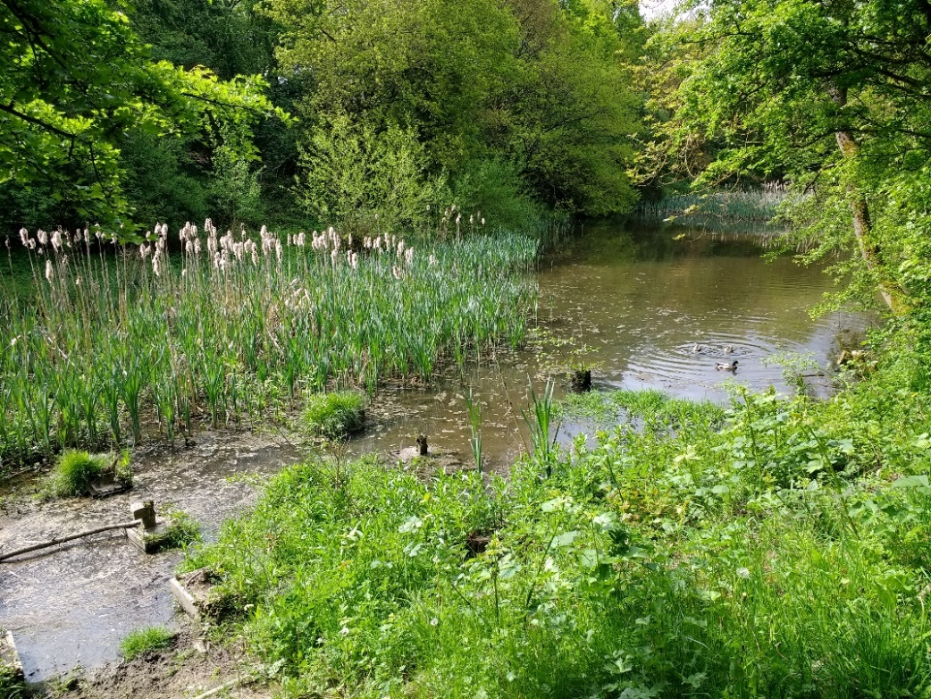

The former pond-dipping platform can be seen in the bottom left corner. We are hoping to replace it soon.

Summary of practical tasks in Quarter 1

- Regular litter picks on site to remove rubbish and recycle cans, bottles and plastic
- Cutting back of low and overhanging branches along the main path
- Cleaning Interpretation panel and notice board
- Clearance work (strimming) of the encroaching vegetation along the main paths.
- Trimming of the hedgerows at and alongside the Reserve entrances.
- Removal of bramble and nettle roots from along the new woodland path and glade
- Clearing, cutting up and stacking the brash and timber from fallen trees.
- Pollarding Willows
- Step repairs
- Sowing Wildflower seed
- Spraying Japanese Knotweed

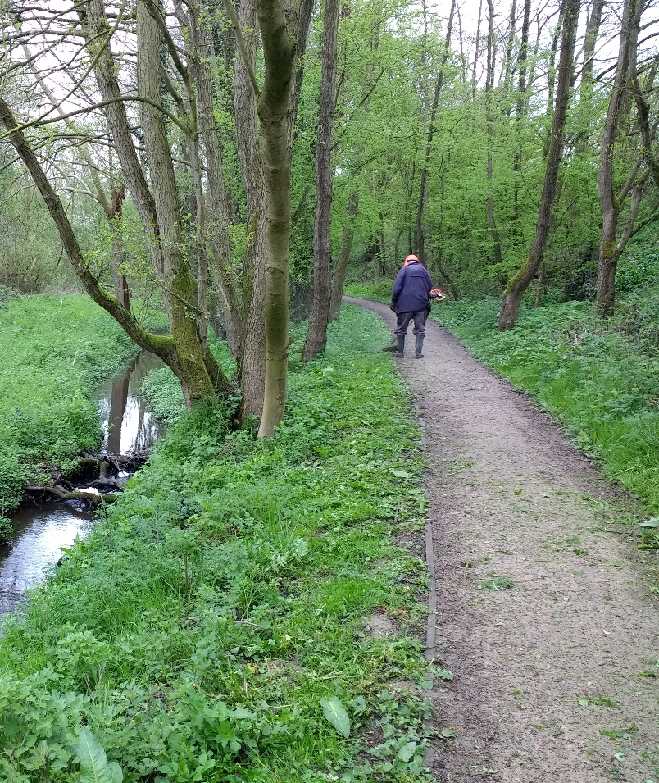
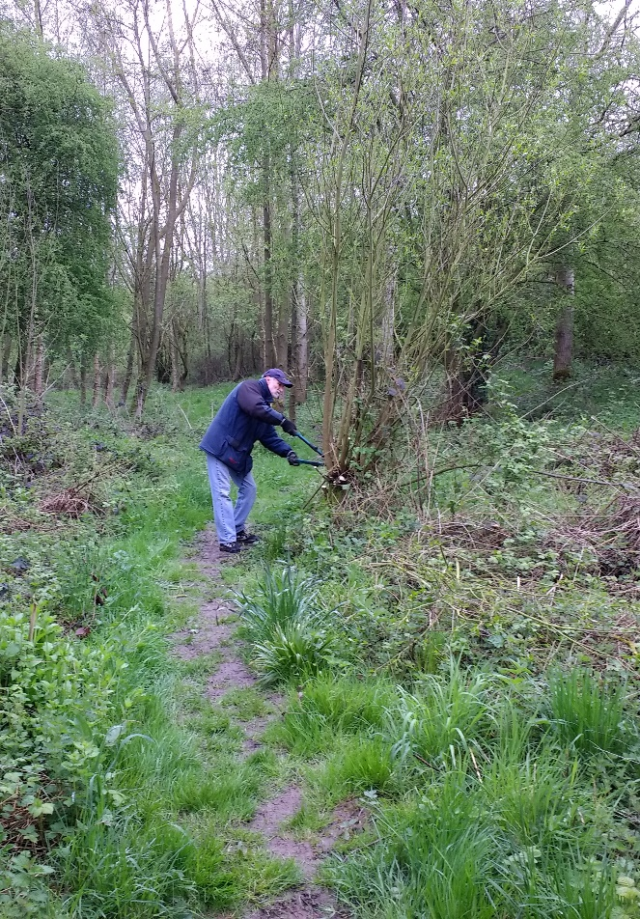

John strimming vegetation along the edge of the path.
Ian pollarding a willow.

Friends of Group (FOG) Task Days

The first action day this quarter was held on Saturday 28th April. It was moved back two weeks from its original scheduled day on the 14th. It was a nice day, warm, dry and sunny and eight volunteers turned up to help. John was strimming along the edges of the path and Anne was clearing up behind him. David and Ben were sorting out a fallen tree, dead hedging the brash and making a timber habitat pile with the logs. Stephen and Ian were digging out and clearing bramble roots, and Kerry and Peter were using some of the materials to thicken up the dead hedge around the meadow. I kept an eye on all of the various tasks whilst carrying out a litter pick and getting some photos of the activities.

The second action day of the quarter was held just two weeks later on May 12th and seven volunteers came along on another lovely day with plenty more sunshine. We carried out some basic maintenance tasks including litter picking, cutting back encroaching vegetation and trimming hedgerows. Chris led a small group on identifying and recording the wildflowers found on the reserve and Ben took on the task of recording the birds to be seen and heard.

The June action day was on Saturday 9th, and it was another warm and sunny day attracting eight volunteers. The number of volunteers attending is holding up well and ensures that we are able to get plenty of tasks completed. We all worked together clearing bramble and nettle roots in the new glade, created by the clearance of the large willow trees. We then prepared the soil (as best we could), and seeded the area with a wildflower seed mixture. Unfortunately since we seeded the area, there has been no rain during the month and no sign yet of any wildflowers germinating. Perhaps we will get some rain in July, but if not, we retained some seed for a second try.

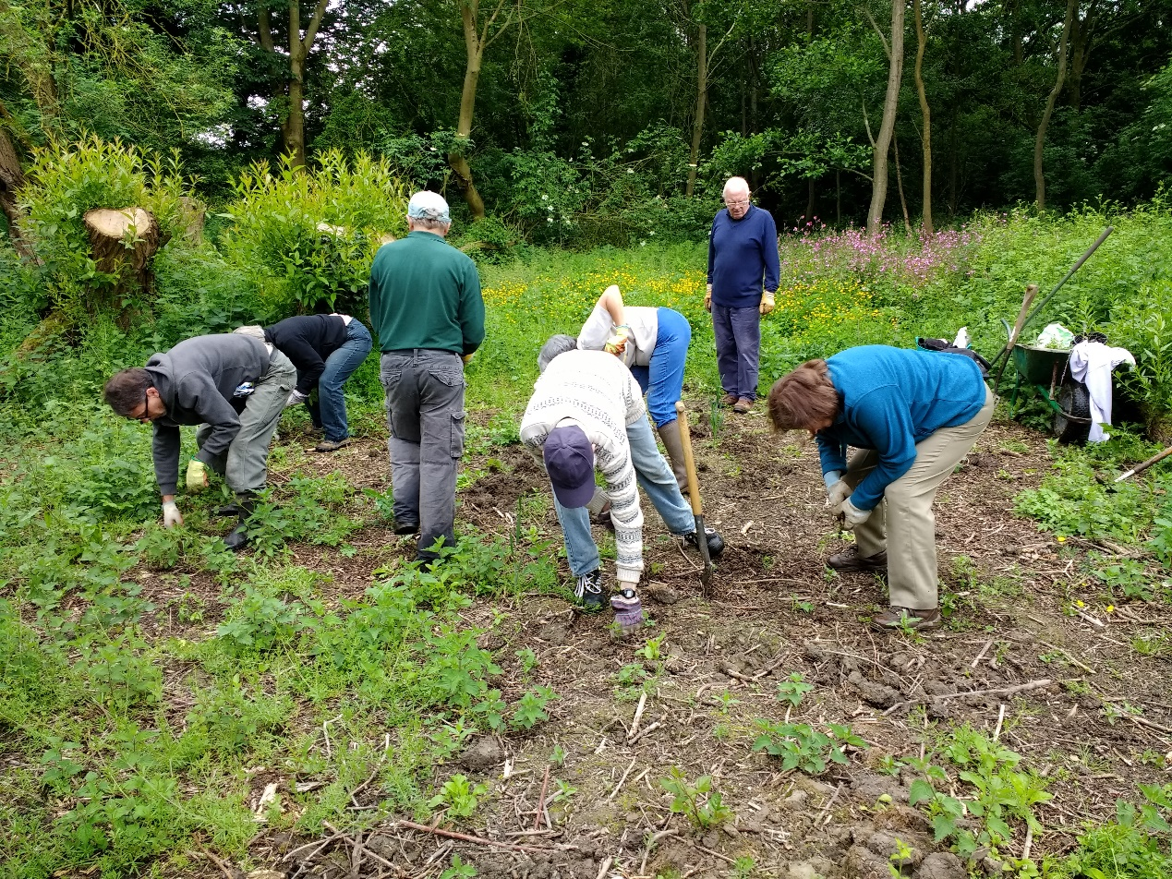

The Friends of Group prepare the clearing for seed planting.

Conservation Volunteer Tasks

We visited the reserve twice during April; the first visit was on Monday 16th April on a warm and sunny day which attracted six volunteers. A small team continued working on clearing the bramble roots from the new glade whilst the larger group trimmed the damaged trees on the bank above the stream opposite and stacked the wood into a habitat pile. There was a lot of litter around, so a litter pick was also necessary.
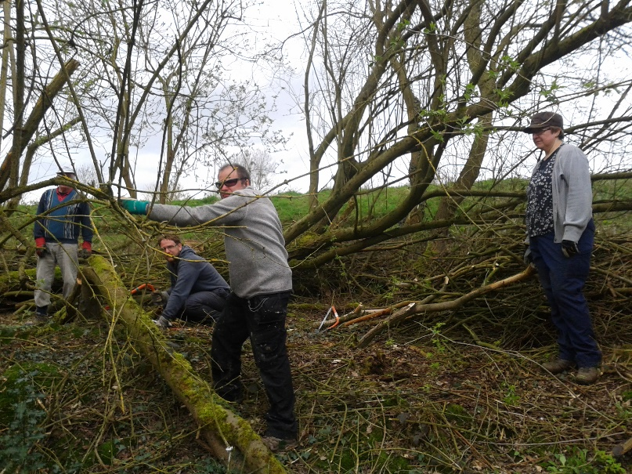
The second visit was on Friday 27th April and it was a very wet and cold day, possibly the last one before the period of hot and sunny weather began. Despite the weather four hardy volunteers turned up. The main job was to continue thinning the trees on the bank above the stream. The bank we are clearing is opposite the area were the large willows were recently removed. We also planted a large Oak tree which had been donated to the group by a member of the public. We finished early in the afternoon as the weather worsened with very heavy rain falling.

We again visited the reserve twice during May on Wednesday 16th and Wednesday 23rd.
The first visit was arranged specially to carry out repairs to the large flight of steps, leading down to the recently replaced bridge at the far end of the reserve. The Friends of Group had purchased the materials required for the task and I met John at his house to collect the timber. It was warm, clear day with weak sunshine and three volunteers turned up to help.
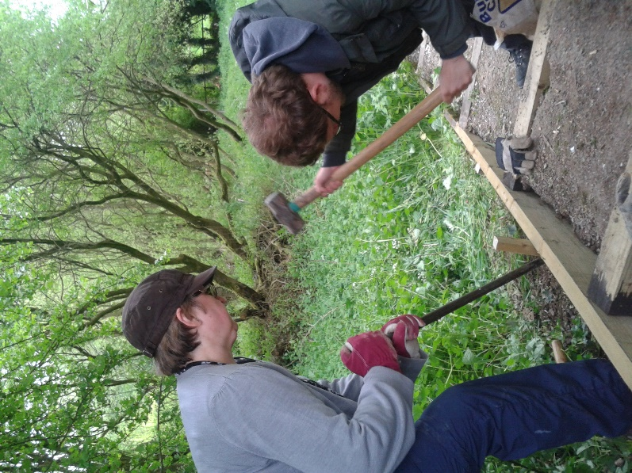
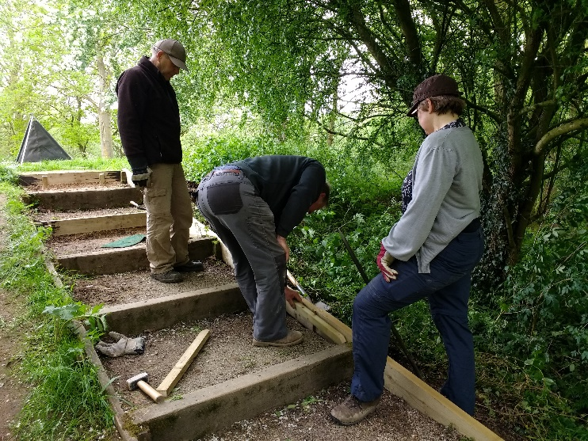
We worked until mid-afternoon to replace four damaged steps and large parts of the side edging board. John still has some timber stored to replace other steps as they deteriorate.
Our second visit, a week later, was again on a warm and sunny day and one of the main tasks was to spray the recently discovered Japanese Knotweed. We thought we had eradicated this with spraying in the past and it has not been seen on site for the past two years. There were two separate areas of a few plants only, in the approximate area of the former plants. As in the past we had the help of the Waingroves Wood Community Group to tackle the Knotweed.
A second task was the continuation of bramble root removal in the new woodland glade and cutting back encroaching vegetation on the access paths.

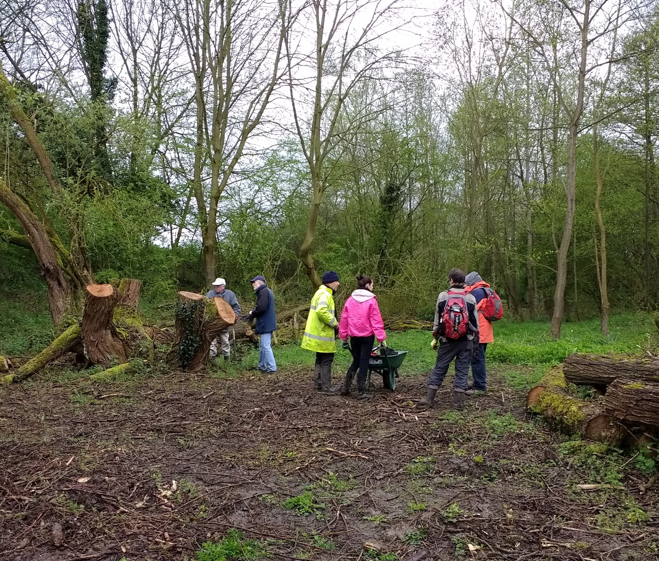
The team receive a briefing before the job begins.

Our only June visit was again hot and sunny, not the best weather for wearing the hot and heavy kit required for strimming the paths. It was on Monday 11th and three volunteers came along to assist. I spent the day strimming the vegetation to create a border to each side of the main paths and Ben, David and Stephen cleared the vegetation, moving it onto the various habitat piles around the reserve. It was a very tiring day for us all, with plenty of drinks breaks needed. We received plenty of favourable comments from the many visitors which, is good for the motivation, it’s really nice to feel appreciated.

Events – Bat and Newt Watch

On Tuesday 22nd May, an evening event was held on the reserve to observe and count the newts and to identify any bats that were around. The event started at 9.00 pm and went on till about 10.45pm; it was fortunately a warm and dry evening and was attended by seven members of the group. Marion Farrell from Groundwork CAM attended with a bat detector, to help identify the bats.
Similar to last year, the pond weed covering the surface of the pond, made newt detection very difficult but both Smooth and Great Crested newts were seen along with many frogs. A number of bats were heard and seen, the two species positively identified, as last year, were Common Pipistrelle and Daubentons.

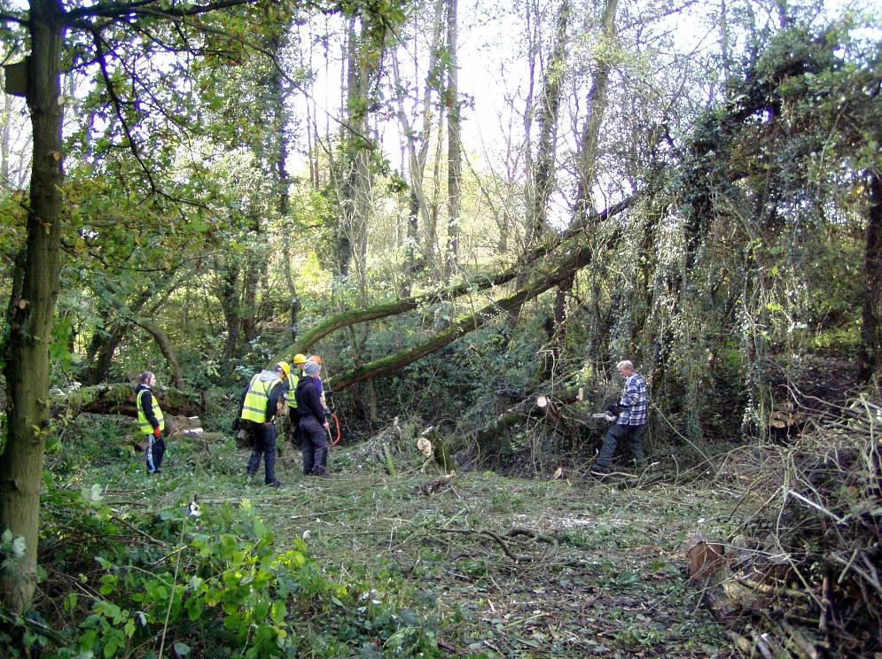
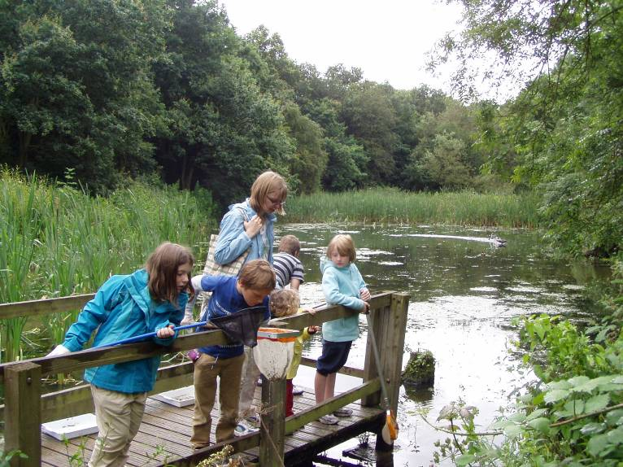
Meetings

There has been one Friends Of Group meeting this quarter, on Wednesday 9th May, six members turned up with apologies sent from two. Items discussed included the Red River leaflet, the logo and the banner. Decisions were made and individuals given the responsibility to move things forward. Reports were received from Alan (Publicity Officer), John (Treasurer) and Celia (Town Council Representative). The meeting then celebrated and discussed the news that the Pond Dipping Platform project has been selected by Tesco to go into the stores for a public vote. We are looking forward to winning the vote, if local people support us in numbers at the Heanor store.
We also discussed the plans for the next two task days on the 12th and 16th May. The newt and bat survey was re-arranged for the 22nd May, following bad weather on the 15th.
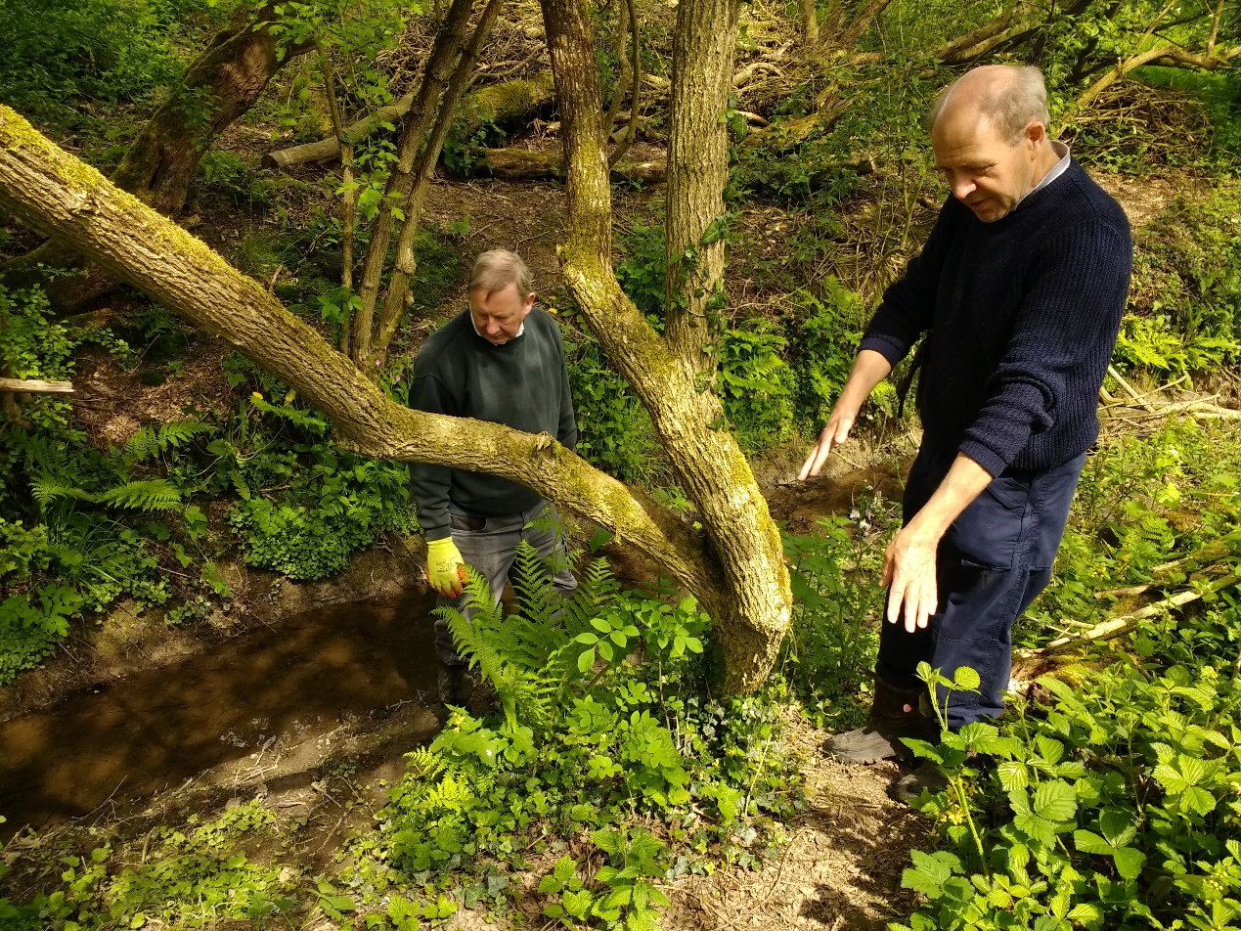
John and I discuss the location of the new bridge to complete the circular route.

Publicity

Publicity Officer
Alan is continuing to promote the group, and the volunteering opportunities, in the local area. Posters and cards have been distributed to a number of local outlets including Heanor Library, the local Tesco Store and Shipley Country Park Visitor Centre.

Get Active! Help Nature Leaflet
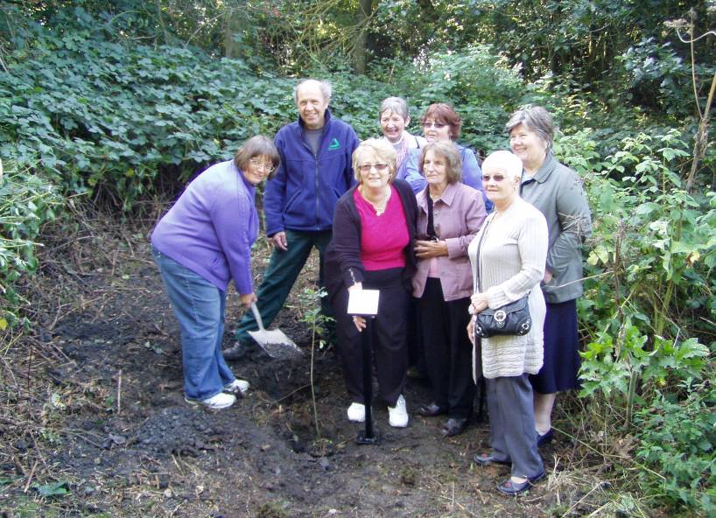
The Nature Reserve continues to be publicised in the Groundwork general leaflet promoting the health benefits of volunteering in the local environment.
I regularly distribute the leaflet to a number of local outlets including Amber Valley CVS. I am often being contacted by potential conservation volunteers and Stephen a recent recruit has now started attending the Red River FOG task days, as he lives locally.

Practical Task Programme
All tasks and events at Red River LNR are promoted on my general task programme. The task programme is produced quarterly and distributed around all the Groundwork Conservation Volunteers working with me. It is also distributed to all members of the numerous Friends of Group who help on the other reserves, in Amber Valley and the Derbyshire Dales.

Tasks and Events
Specific tasks and events are promoted by posters distributed locally, including the reserve notice board, the Tesco community board and the visitor centre at Shipley Country Park. The recent Newt and Bat watch evening was attended by seven Friends of Group members.

Funding
The group and I continue to seek out funding opportunities to support our work on the reserve.
A bid was recently written and submitted to the Tesco Bags of Help scheme to secure funding to replace the Pond Dipping platform. We were lucky in getting the bid selected, nationally, to go the public vote in the Derby area, which includes the local Heanor store. It will be voted on during May and June and we will hear in mid July how much we have been awarded. Three projects are in competition for £4000, £2000 and £1000, so we assured of some funding towards the project.
Groundwork is partnering Tesco in this Scheme and my role is to act as the community enabler for the Alfreton, Derby and Ilkeston areas. This means I promote and support bids within these Tesco areas, so I have to be one step removed from any bid submitted by the groups I assist.

Most of the £840 from the Derbyshire County Council Members’ Community Leadership Scheme has been used to fund the felling off the dangerous willow trees by AA tree surgeons. Remaining funds are earmarked for future projects in the same area; wildflower seed, plug plants, hedging plants and the costs of an expert guide for a guided walk/launch event.
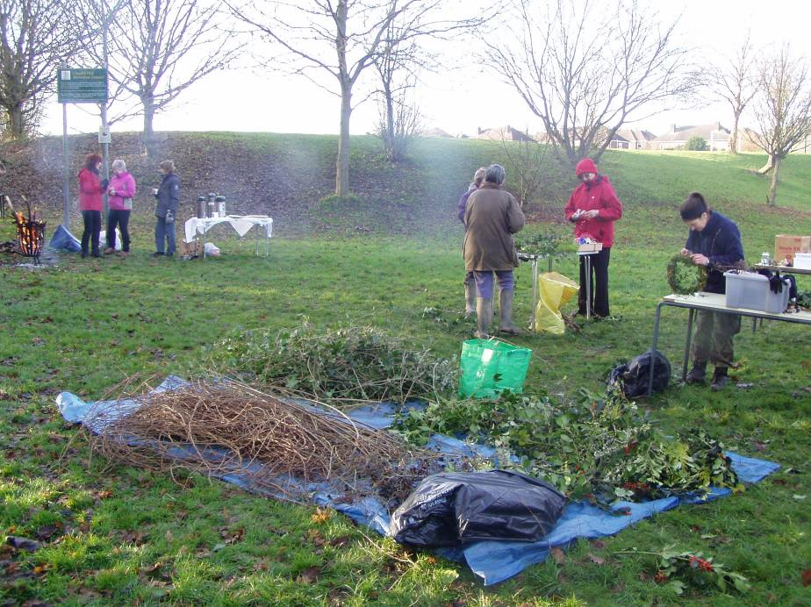
Statistics

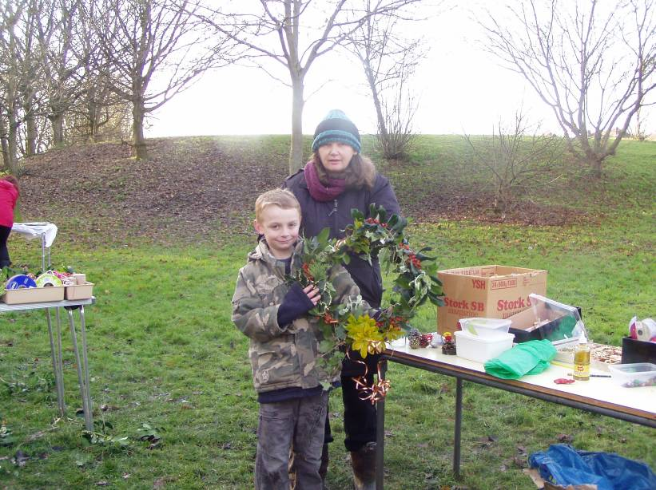
Summary Statistics - Quarter 1
No. of individual volunteers on practical tasks | 13
No. of individual volunteers on events | 1
No. of individual volunteers on wildlife recording | 3
No. of Friends of Group meetings/action days attended | 3
No. of Practical volunteer days contributed by adult volunteers (159.5 hours divide by 6 hours) = | 26.6
No. of volunteer days contributed by volunteers on wildlife recording (18 hours divide by 6 hours) = | 3
No. of practical volunteer days contributed by young people | 0
No of days on events contributed by volunteers | 0.5
No. of adults attending events | 7
No. of children attending events | 0
No of activities/events/practical days delivered by GCAM | 9
No of wildlife recording visits delivered by GCAM | 3
No of additional days spent on site by extra Groundwork Staff | 0
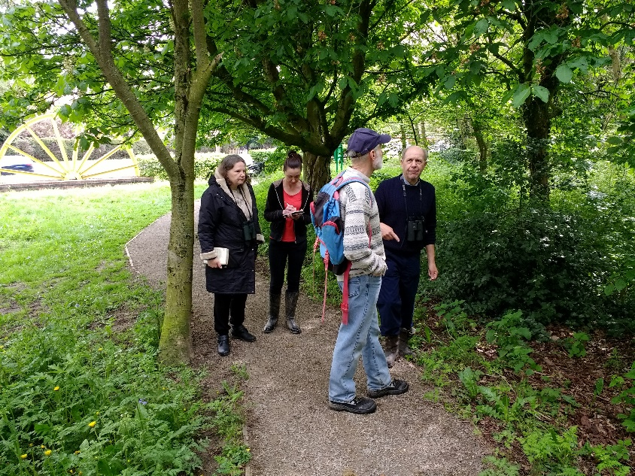

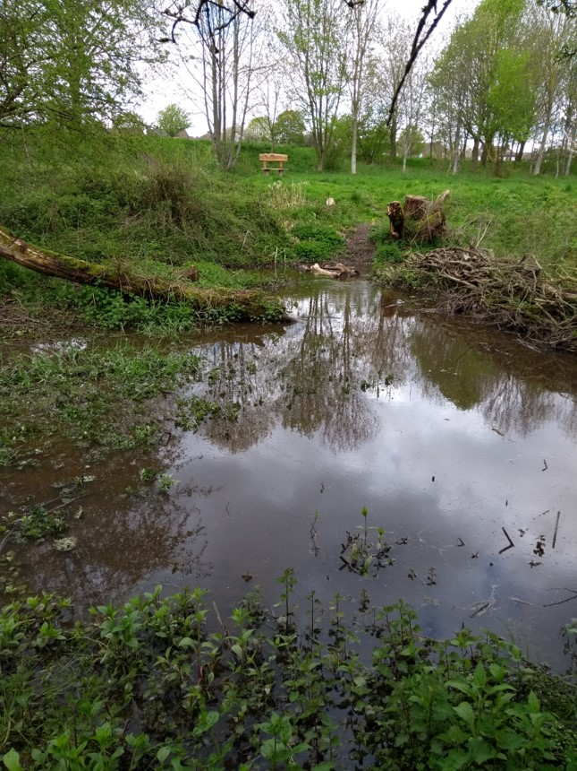

The Friends of Group record wildlife at Red River.

Volunteer Information - Quarter 1

Male volunteers | 8
Female Volunteers | 5
Unemployed | 4
Employed | 5
Retired | 4
Students | 0
Registered Disabled / Health problem | 4
Under 18 | 0
Aged 18-25 | 0
Aged 26-40 | 3
Aged 41-65 | 8
Over 65 | 2

The flooding at the end of April before the long summer started.

Wildlife Recording

I look and listen out for wildlife on most of my visits to the reserve, but often I am too involved with the practical tasks and supervising the volunteers to, systematically, record everything seen or heard.
I am continuing the half-day wildlife recording visit to the reserve each month, to check and record our wildlife visitors.

I have spent two/three hours recording on the reserve each month this quarter; Saturday 28th April, Wednesday 23rd May and Monday 23rd June. These monthly recording visits help to build up a picture of what is likely to be seen during the year, and gives a more comprehensive idea of what wildlife is around on the reserve. These types of records become more valuable over time and help to monitor changing and improving habitats on the reserve.

Birds

This quarter last year we spotted 28 different birds. This year in the first quarter we have spotted or heard a magnificent total of 35 species of bird.

- Wood Pigeon
- Stock Dove
- Collared Dove
- G. S. Woodpecker
- Green Woodpecker
- Mistle Thrush
- Song Thrush
- Blackbird
- Swift

- Crow
- Magpie
- Jay
- Starling
- Goldcrest
- Blackcap
- Chiff Chaff
- Nuthatch
- Tree Creeper

- Great Tit
- Blue Tit
- Long Tailed Tit
- Mallard
- Moorhen
- Robin
- Wren
- Pheasant
- House Sparrow

- Bullfinch
- Chaffinch
- Greenfinch
- Goldfinch
- Buzzard
- Dunnock
- Grey Wagtail
- Pied Wagtail

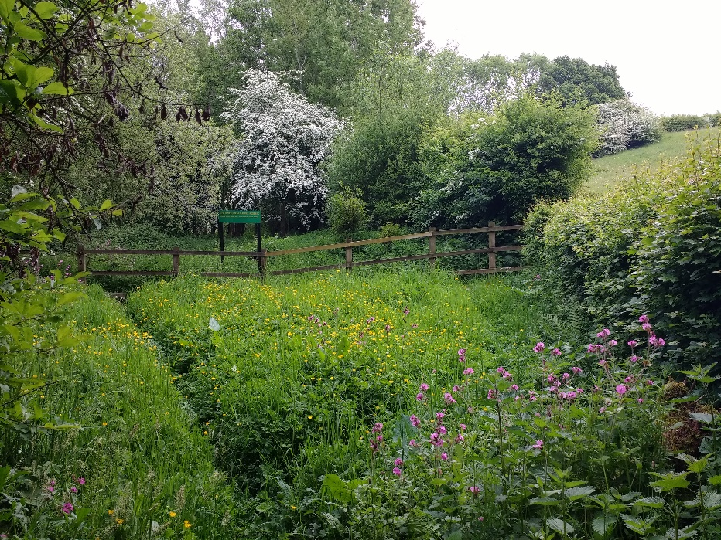
Butterflies
Butterfly sightings between April and June have included Peacock, Brimstone, Small White, Speckled Wood, Gatekeeper, Green Veined White, Meadow Brown, Red Admiral, Large Skipper, Small Skipper, Large White, Small Copper, Small Tortoiseshell and Ringlet.

The Jubilee Meadow (opposite) is an excellent habitat for butterflies during Spring.

Monthly Records
The month by month summary is shown below:

April
The wet weather from the previous quarter and the warm weather in April encouraged many wildflowers to flower earlier than normal. The following plants were all in flower during April, many at the same time. By mid month we recorded Lesser Celandine, Primrose, Cowslip, White Dead Nettle, Forget-me-not, Daffodil and Fritillary, which is now found in two separate locations. Blackthorn was in blossom and Hawthorn in leaf. By the end of the month, Bluebells, Red Campion, Ramsons, Dog Violet and Yellow Archangel were also flowering. (A selection of these flowers are pictured below).
Bird sightings were also exceptional, with a magnificent 28 species seen during the task day on Monday 16th; these included unusual sightings of Tree Creeper, Green Woodpecker, Stock Dove and Grey Wagtail. Summer visitors included Chiff Chaff and Blackcap. On the 28th we saw Goldcrest, Buzzard, Nuthatch and both Song and Mistle Thrush.

There was a lot of activity from the frogs and newts in the pond. Early butterflies included Peacock and Brimstone.
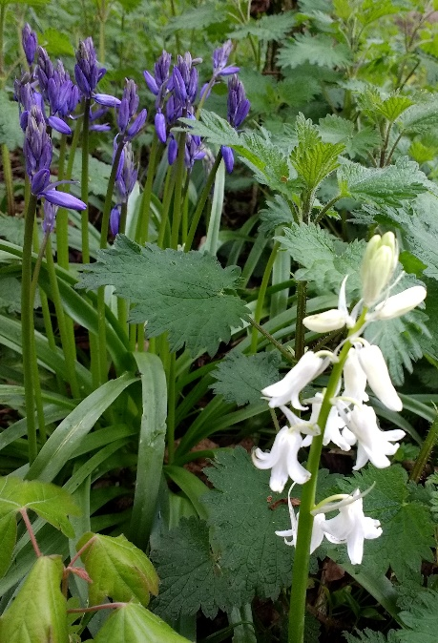
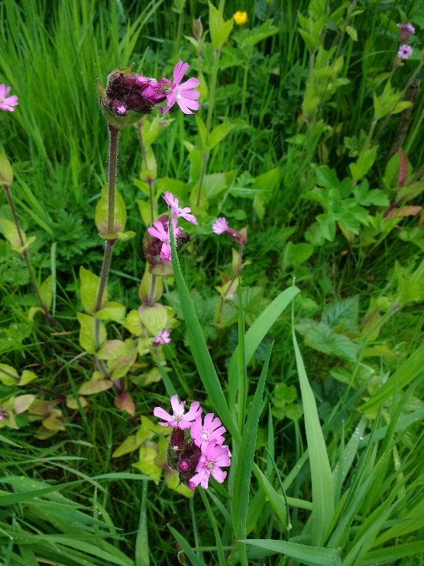
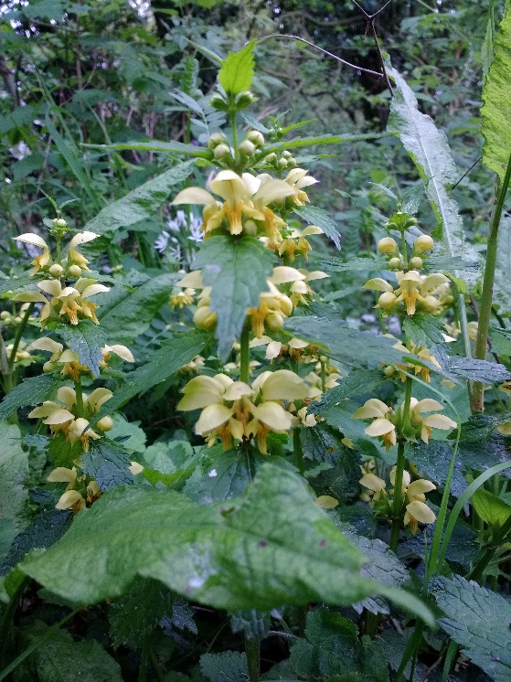

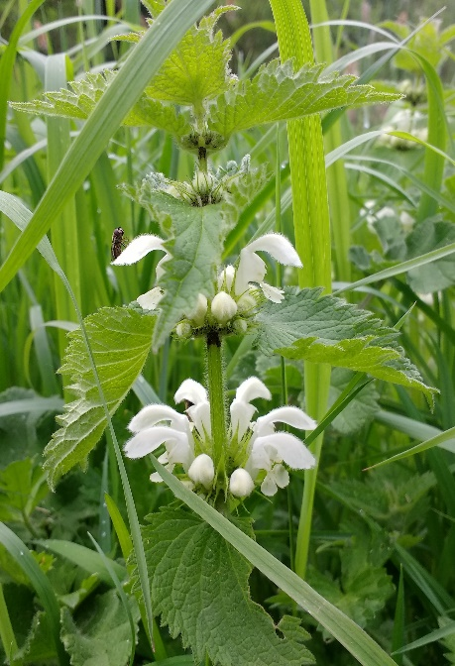

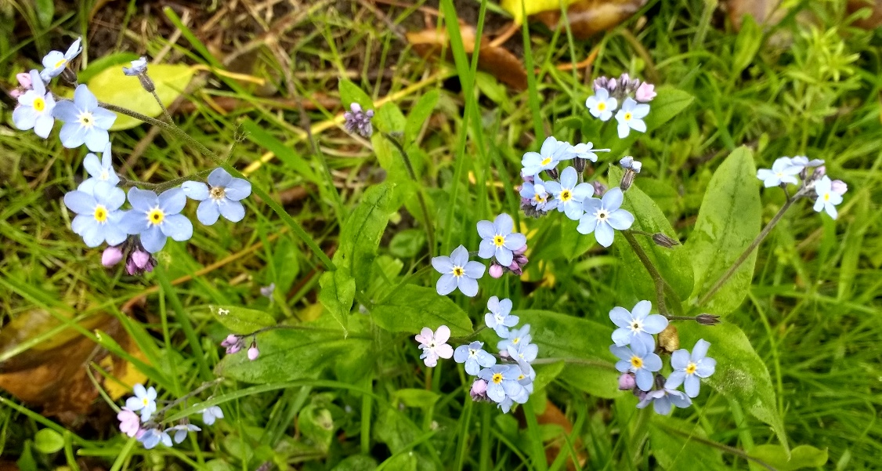

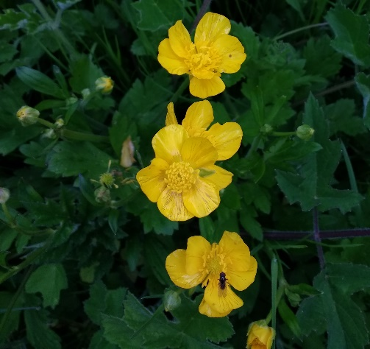
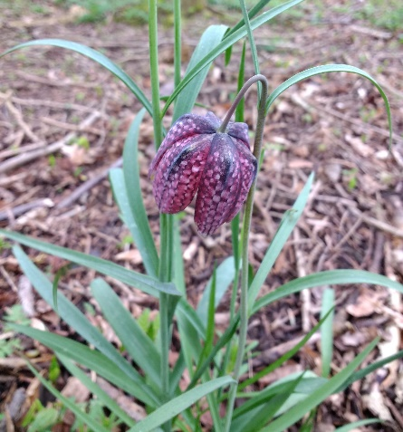
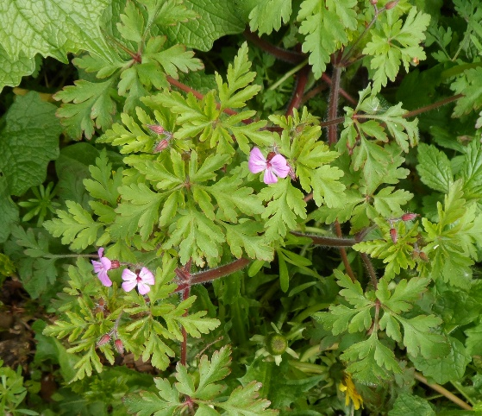

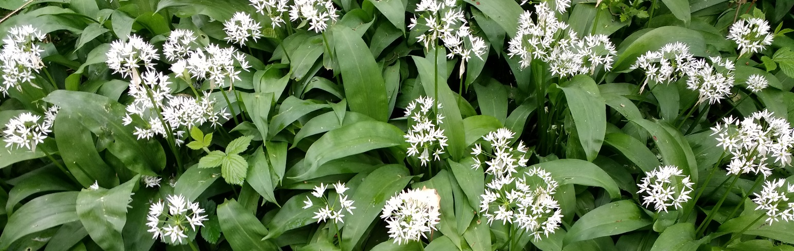

May
Butterfly sightings included Speckled Wood, Large Skipper, Meadow Brown and all three whites, Large, Small and Green Veined.
The highlight of the month was spotting two Grey Wagtails feeding along the stream bed. Other notable sightings included Greenfinch, Wren, Bullfinch, Great Spotted Woodpecker and the Swifts were back; earlier in the year than normal. Both Mallard and Moorhen were seen on the pond with young chicks.
Plants in flower included Lesser Stichwort, Daisy, Herb Robert, Birds Eye Speedwell and Rose Bay Willow Herb. The pond was looking well with Water Mint, Water Forget-me-not, Water Bistort, Water Avens and Yellow Flag Iris all in flower. The water levels were staying high despite the continuing warm and dry weather, although there may be problems ahead if the weather continues throughout June. The Newt surveying event on the 22nd recorded both Smooth and Great Crested Newts, as well as lots of Frogs.

June
Most plants have been flowering for ages, but new sightings in June included Foxglove, Meadow Cranesbill, Meadow Sweet, Yellow Rattle, Meadow Buttercup and Creeping Buttercup. The butterfly friendly Birds Foot Trefoil, (known locally as eggs and bacon), continues to do well in the wildflower meadow.
The highlights of the many butterflies enjoying the uncommonly warm and sunny weather were Red Admiral, Peacock, Gatekeeper, Small Copper and Small Skipper. Towards the end of the quarter, there were dozens of Ringlets and Meadow Browns seen on the reserve.
There were many young birds seen during the month, including Blue Tits and Great Tits (nesting in our nest boxes). We also saw young Robins, Wrens, Goldfinches and Chaffinches. There were young Mallards and Moorhens on the pond, which is starting to look badly in need of rain, with lots of mud now in evidence.
Future Tasks

During Quarter 2 (July to September 2018) the following meetings/practical days/events/activities are planned (please check with me before attending, as these dates may change):-

Wednesday 11th July FOG Meeting
Saturday 14th July FOG Action Day
Tuesday 17th July Newt Survey and Bat recording
Wednesday 25th July Conservation Volunteers Task Day
Thursday 26th July Wildlife Recording Visit

Saturday 11th August FOG Action Day
Monday 13th August Wildlife Recording Visit
Friday 17th August Conservation Volunteers Task Day
Saturday 25th August Conservation Volunteers Task Day

Monday 3rd Sept Conservation Volunteers Task Day
Wednesday 5th Sept FOG Meeting
Saturday 8th Sept FOG Action Day
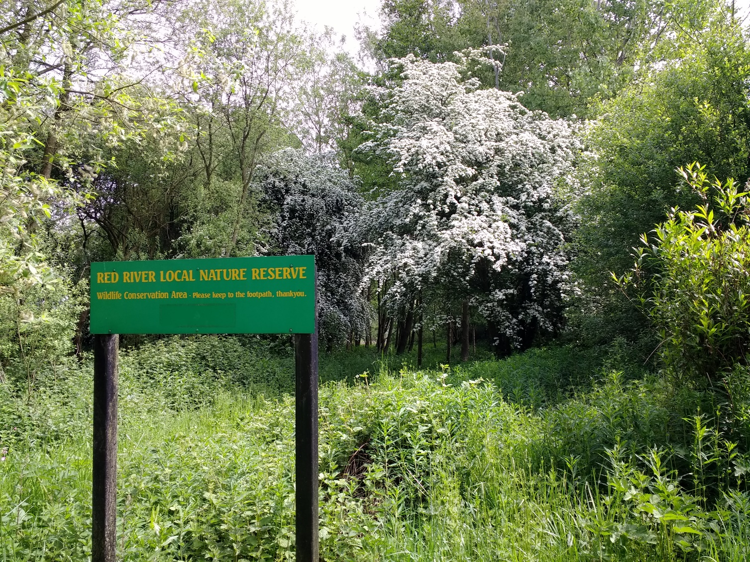
Wednesday 26th Sept Wildlife Recording Visit and Task Day

