**G:\LOGOS\Groundwork - Changing Places Changing Lives.wmfRED RIVER LNR**

**Quarter 1 SLA Report for April - June2019**

**General background, aims and objectives**

The aim is to work in partnership with the Friends of Red River community group to deliver an annual work programme, agreed with Heanor and Loscoe Town Council representatives, on the Red River Local Nature Reserve at Loscoe.

The intention is to improve the site for the benefit of the local community by ensuring public access, and to manage, maintain and develop the site to improve habitats and encourage bio-diversity of species. The Local Nature Reserve is home to a variety of both local and visiting wildlife. Regular wildlife recording visits are made to record the changing wildlife throughout the seasons.

Additional funding will be sought to deliver a selection of environmental events, activities and guided walks to ensure ongoing public interest and involvement.

**Volunteer Practical Activities**

Scenic view

During this quarter, there have been four Groundwork conservation volunteer days and three Friends of Group Saturday morning action days completed. The attendance of friends of group members on the practical days continues to be really good with attendance regularly in double figures.

Over the three months, we have had 20.7practical volunteer days completed by adults on the reserve and 19 different adults have been involved in volunteering on the reserve during this quarter.

I have also visited with volunteers on three half days, one each month, to record the wildlife on the reserve.

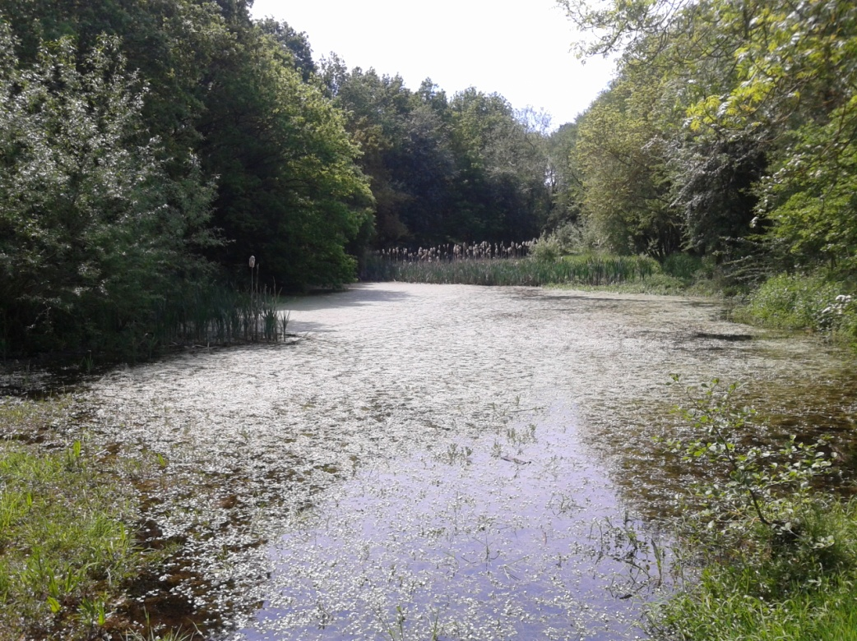

**Summary of practical tasks in Quarter 1**

* Regular litter picks on site to remove rubbish and recycle cans, bottles and plastic
* Cutting back of low and overhanging branches along the main paths and removing fallen trees
* Removal of interpretation panel for repair and cleaning
* Clearance work (strimming and mowing) the encroaching vegetation along all the paths
* Trimming of the hedgerows at and alongside the Reserve entrances.
* Installed wildflower coir mats in pond and stream
* Removing Hogweed plants from wildflower meadows
* Clearing vegetation around the Hazel coppice trees
* Painting entrance gate
* Repairs and replacement of steps leading to dipping platform
* Sowing Wildflower seed

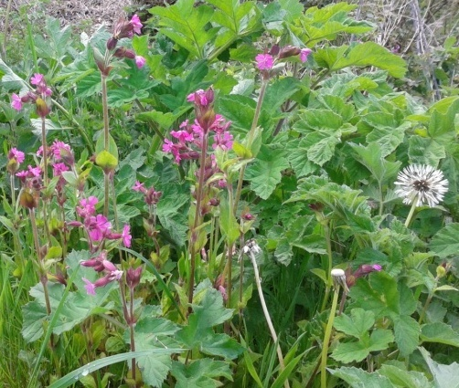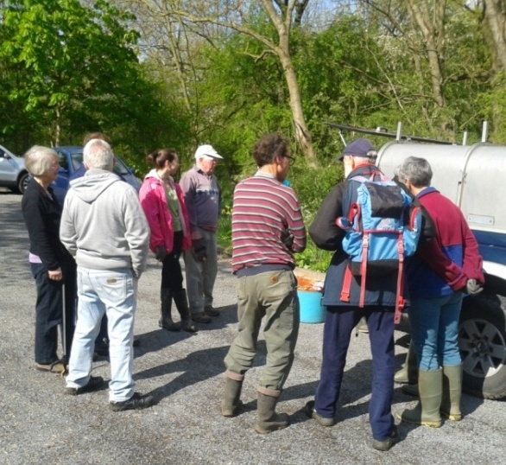

The Friends of Group gather in the morning

Herb Robert

**Friends of Group (FOG) Task Days**

The first action day this quarter was held on Saturday 13th **April.** It was a warm, dry and sunny day and eleven volunteers came along to help. Tasks included clearing encroaching vegetation along the main path, clearing bramble and blackthorn on the slopes to the side of the main path and sowing wildflower and grass seed on the new, recently cleared, meadow extension. We also cleared the litter from the reserve.

The second action day of the quarter was held on **May** 11th and fourteen volunteers came along on a lovely warm and sunny morning. A fantastic attendance, which enables us to get lots of tasks completed. We carried out some basic maintenance tasks including litter picking, cutting back encroaching vegetation and trimming hedgerows. Other tasks included;-

* Strimming path edges

Painting the entrance gate

* Painting the entrance gate
* Clearing around the Hazel coppice trees
* 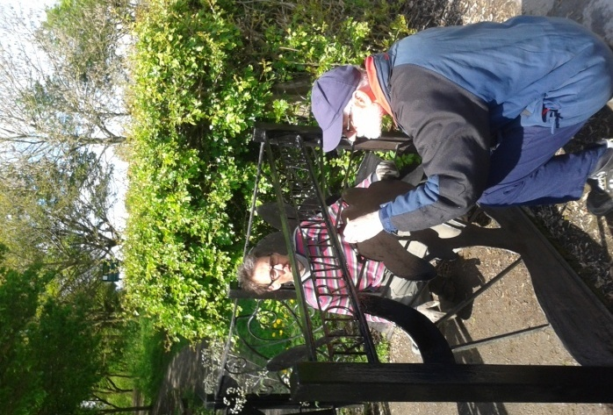Removing Hogweed and Nettle from the meadows
* Clearing Bramble and Blackthorn from the banks
* Moving the interpretation sign for repairs

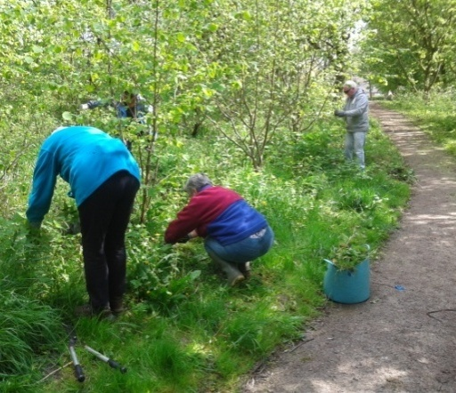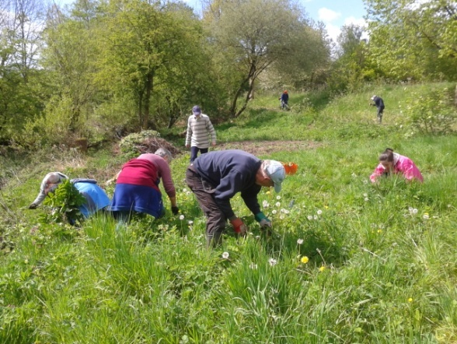

Clearing the coppice

Removing Hogweed

The **June** action day was on Saturday 8th. It was also the date selected for the launch of the pond dipping platform and we were expecting a number of VIP’s. I had arranged for five of the volunteers to arrive early to help get ready for the 10am dipping platform launch ceremony. It was a warm morning but unfortunately there was persistent light rain with occasional heavier showers. Despite the weather 9 volunteers turned up.

The volunteers and visiting guests were all in place by 10am; they included Cllr Oakes the Heanor and Loscoe Mayor together with Cllr Cox and Cllr Carmichael from Heanor and Loscoe Town Council, Cllr Iliffe from Derbyshire County Council and Jodie Abbott, the Community Champion from the local Tesco store.

The ribbon was cut by the mayor, lots of photographs were taken and then refreshments were available including a selection of home-made cakes, which proved very popular.

Earlier that morning I had taken delivery of the new Red River Nature Trail leaflet, so we took the opportunity to launch this leaflet at the same time and distributed a copy to each of the 18 people who attended the ceremony, 9 volunteers, 5 VIP’s and 4 members of the public.

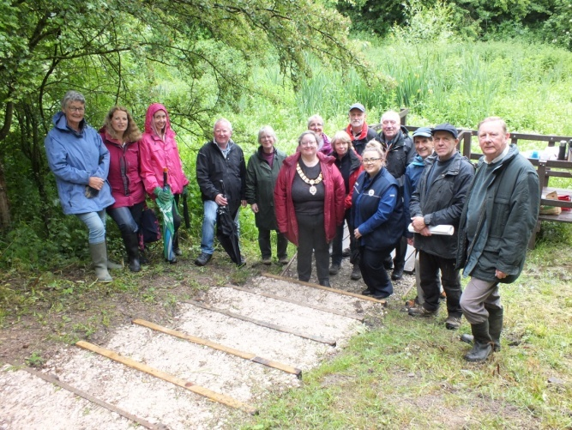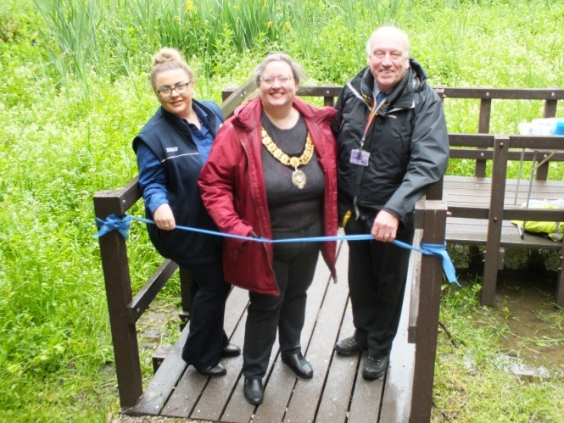

Launching the new Pond dipping platform

Following the launch, at 11am, we held a normal volunteer task day; all of us working together to cut up and clear a large fallen tree. It had fallen across the stream and into the new glade which we are starting to develop as a butterfly friendly wildflower area. We cleared all the branches and incorporated the timber and brash into an existing habitat pile, just leaving the main trunk to be tackled at a later date. The three town councillors stayed on and undertook a thorough litter pick on and around the reserve. We completed the tasks at around 12.30 just in time to avoid the heavy rain which came in for the afternoon.

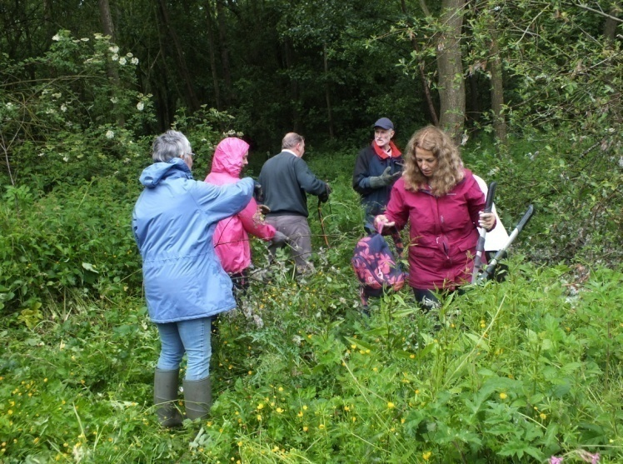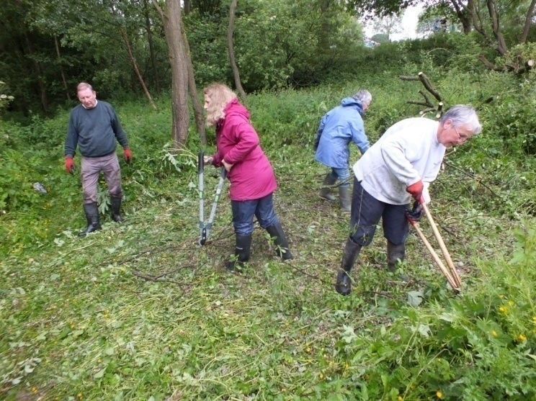

The Friends of Group clear the meadow

**Conservation Volunteer Tasks**

We visited the reserve twice during **April**; the first visit was on Friday 5th April, a fine, dry but overcast day, which attracted three volunteers. There were two small trees fallen and overhanging the path. We worked on bringing these down and cutting them up and removing the timber and brash onto the nearby habitat piles. We also put three wildflower coir mats into the stream and pond; these had been provided for us free by Julie from the Trent Rivers Trust, but were worth £60 each.

The second visit was on Monday 15th April and it was a very warm and sunny morning. We worked on cutting back the regenerating willow shoots on the previously felled large Willow trees. Three of the volunteers then helped me with cutting back the Bramble and Blackthorn to allow access to hedgerow on the boundary with the farmland. We are planning to hedge-lay this in the autumn. The fourth volunteers mowed along the grassy path giving access through the woodland.

We visited the reserve once during **May** on Wednesday 15th. It was a very hot and sunny day and we were unfortunately working in full sun, replacing and repairing the steps leading to the, recently installed, pond dipping platform. I was working with three members of the friends of group and one of my conservation volunteer team, so there were enough people to carry the heavy timber and stone to site. We replaced three steps completely and repaired and levelled two others. We got some very complimentary comments from the many people who passed along the main path. It was actually a very satisfying and rewarding job, but we were very hot and tired by the time we had finished.

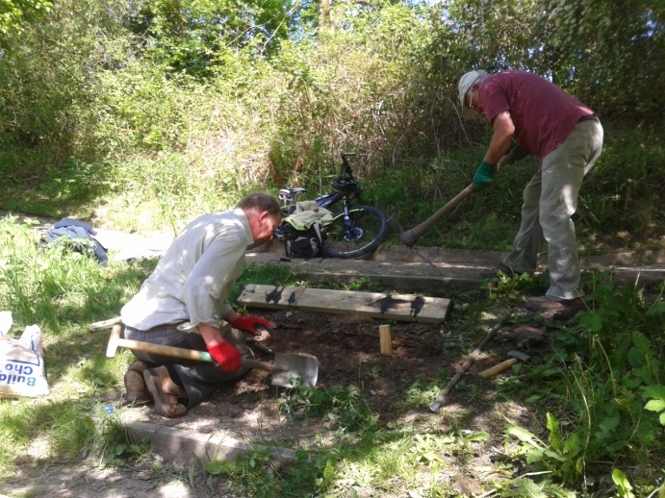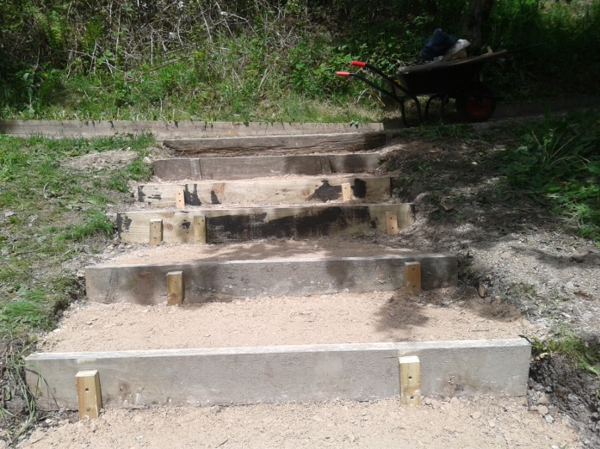

Repairing the steps

Our final visit of the quarter was on Wednesday 12th **June,** another fine and dry day but fortunately a little cooler. A lot of the volunteers were off on holidays, so just one volunteer was with me. We concentrated on clearing the vegetation and low tree growth along all the main paths and entrances and from around and under the benches. We again received plenty of favourable comments from the many visitors which, is good for the motivation, it’s really nice to feel that the work is appreciated.

**Events –** Bat and Newt Watch

There have been two of our regular summer newt and bat watches this quarter. On Tuesday 29th **May**, three FOG members met with Marion from Groundwork at 9.15pm. Marion brings along a bat detector which helps to identify the bats by the different sonic frequencies of their calls. The most commonly recorded bats at the Red River reserve are the Common Pipistrelle, the Soprano Pipistrelle and the Daubentons, which can be seen flying low over the pond catching insects.

The second event was on Tuesday 25th **June** and the group of 5 met at 9.30pm. Amphibians recorded include the Great Crested Newt, the Smooth (Common) Newt as well as numerous Frogs and the occasional Toad. The Newt recording was much easier this year. It was helped immensely by the replacement of the pond dipping platform which allows far easier access to and over the water. The newts are observed by shining high powered torches into the water.

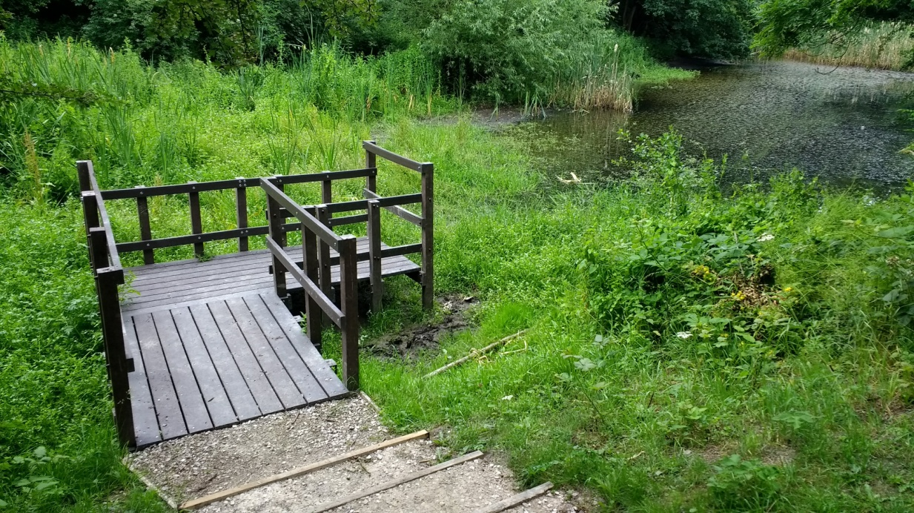

**Meetings**

There have been two Friends Of Group meeting this quarter, one regular scheduled meeting in May, which was to be preceded by the AGM and a special meeting in June to discuss the groups involvement with the Charles Hill Fun Day being organised by Amber Valley CVS.

On Wednesday 8th June, eight members turned up for the AGM at 7pm which was to be followed at 7.30 by the regular group committee meeting.

At the AGM, we received reports from the Chairman and the Treasurer and then the previous committee were re elected to their positions.

The normal meeting received an update from the HLTC representative giving news of the councillors who will be attending the group’s activities in the forthcoming year, Cllr Celia Cox and Cllr Frank Carmichael. Also discussed was the soon to be printed Red River leaflet, which we are hoping to receive before the pond dipping launch event on Saturday 8th June. Other items discussed included the plans for the launch event identifying tasks to people to ensure the event went smoothly; the publicity officer tabled a new volunteer recruitment poster which was well received and will come straight into use; the tasks for the next two action days were also discussed .

The second meeting was held on Wednesday 26th June and was attended by Kirsty Barker from Amber Valley CVS and five FOG members including the Treasurer and Secretary. It was called as a special meeting to discuss the Friend of Groups and Groundwork’s involvement in The Charles Hill Fun Day. It was agreed that group members would have a stall on the Charles Hill playing fields to promote the reserve and the volunteering opportunities for local people and also lead a guided walk around the local area Groundwork with the support of group members would run pond dipping sessions and lead guided nature walks through the reserve. There would also be a self guided trail available for the public utilising the recently produced nature trail leaflet with points highlighted around the reserve to match the habitats highlighted in the leaflet.

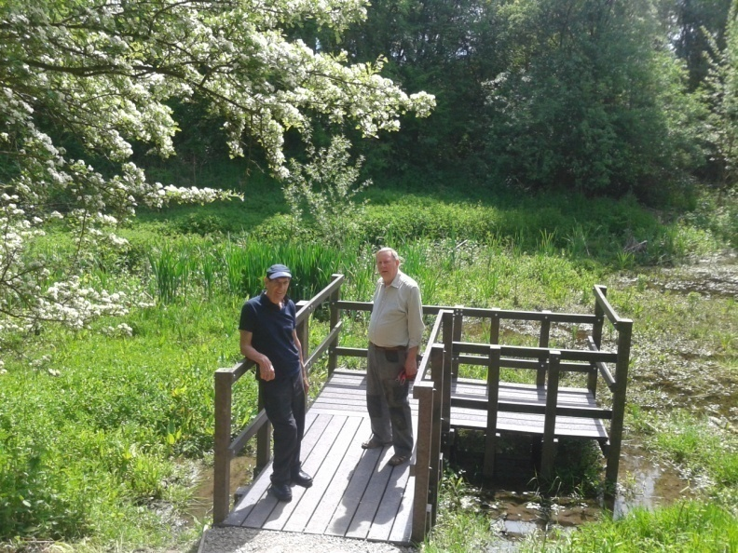

The new platform

**Publicity**

**Publicity Officer**

Alan is continuing to promote the group, and the volunteering opportunities, in the local area. He has recently produced a new recruitment poster which has now been distributed to many local outlets including Heanor Library, the local Tesco Store, Shipley Country Park Visitor Centre and other local shops within Loscoe and Heanor.

**Get Active! Help Nature Leaflet**

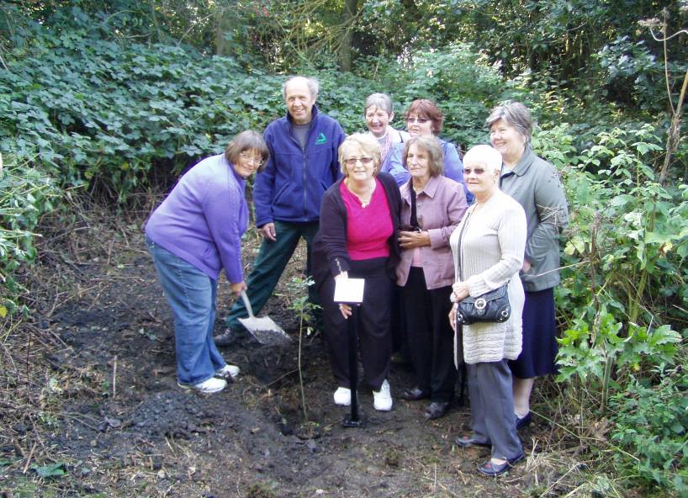The Get Active! Help Nature volunteer leaflet has recently been revamped with a picture from the Red River Nature Reserve on the front. A number of Local Nature Reserves continue to be promoted in the Groundwork leaflet promoting the health benefits of volunteering in the local environment.

The leaflet is regularly distributed to local outlets including Amber Valley CVS, Heanor Library and the visitor centre at Shipley Country Park. I am often contacted by potential conservation volunteers, who have heard of the volunteering opportunities and discovered the local nature reserves by viewing the leaflet. Some of these volunteers also join one of the local Friends of groups close to their homes.

**Practical Task Programme**

All tasks and events at Red River LNR are promoted on my general task programme. The task programme is produced quarterly and distributed around all the Groundwork Conservation Volunteers working with me. It is also distributed to all members of the numerous Friends of Group who help on the other reserves, in Amber Valley and the Derbyshire Dales. The July to September task programme has recently been produced and distributed.

**Tasks and Events**

Specific tasks and events are promoted by posters distributed locally, including the reserve notice board, the Tesco community board and the visitor centre at Shipley Country Park.The current Newt and Bat watch events have been attended by many of the Friends of Group members.

**Funding**

The group and I continue to seek out funding opportunities to support our work on the reserve.

The group are currently writing the final project report for the Pond Dipping Platform funding. It will include details and photos from the recent launce event. It will soon be sent to Tesco to release the final amount of the grant payment. We will then be able to discuss projects for a further Tesco Bags of Help bid.

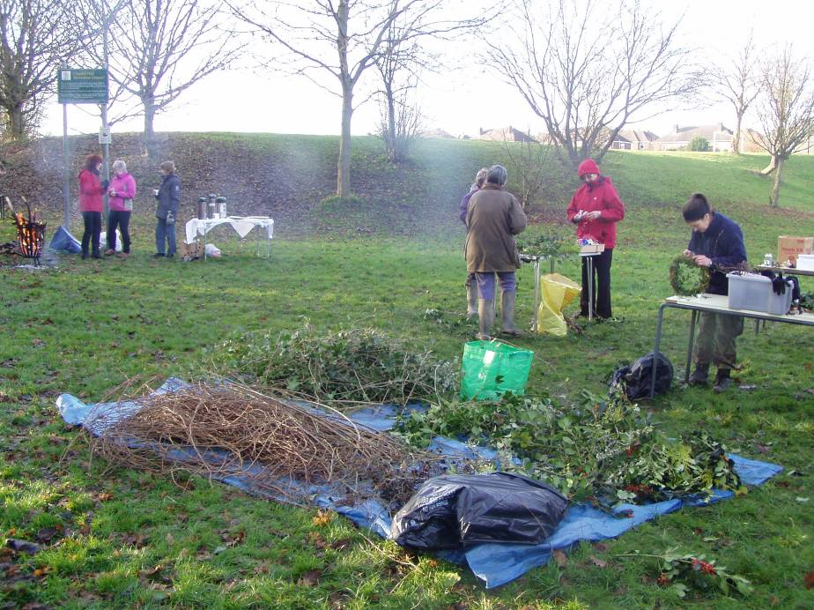**Statistics**

|  |  |
| --- | --- |
| P1010203**Summary Statistics - Quarter1** |  |
| No. of individual volunteers on practical tasks | 19 |
| No. of individual volunteers on events | 8 |
| No. of individual volunteers on wildlife recording | 3 |
| No. of Friends of Group meetings/action days attended | 4 |
| No. of Practical volunteer days contributed by adult volunteers (124 hours divide by 6 hours) = | 20.7 |
| No. of volunteer days contributed by volunteers on wildlife recording (21 hours divide by 6 hours) = | 3.5 |
| No. of practical volunteer days contributed by young people | 0 |
| No of days on events contributed by volunteers (16 hours divide by 6 hours) = | 2.7 |
| No. of adults attending events | 8 |
| No. of children attending events | 0 |
| No of activities/events/practical days delivered by GCAM | 7 |
| No of wildlife recording visits delivered by GCAM | 3 |
| No of additional days spent on site by extra Groundwork Staff | 0 |

**Wildlife Recording**

I look and listen out for wildlife on most of my visits to the reserve, but often I am too involved with the practical tasks and supervising the volunteers to, systematically, record everything seen or heard.

I am, therefore, continuing the half-day wildlife recording visit to the reserve each month, to check and record our wildlife visitors.

I have spent two to three hours recording wildlife on the reserve each month this quarter; Wednesday 10th April, Wednesday 22nd May and Monday 24th June. I have been helped on these recording sessions by three of my regular team of volunteers.

These monthly recording visits help to build up a picture of what is likely to be seen during the year, and gives a more comprehensive idea of what wildlife is around on the reserve. These types of records become more valuable over time and help to monitor changing and improving habitats on the reserve.

**Birds**

This quarter last year we spotted 35 different species of bird, which was a quarterly record. This year in the first quarter we have managed to beat it, spotting or hearing a total of 36 species of bird. We have missed Goldcrest, House Sparrow, Collared Dove and Grey Wagtail, which we recorded last year. We will be aiming for 40 species next year!!

* Great Tit
* Blue Tit
* Long Tailed Tit
* Mallard
* Moorhen
* Robin
* Wren
* Pheasant
* Pied Wagtail
* Bullfinch
* Chaffinch
* Greenfinch
* Goldfinch
* Buzzard
* Sparrow Hawk
* Dunnock
* B. H. Gull
* Willow Warbler
* Wood Pigeon
* Stock Dove
* G. S. Woodpecker
* Green Woodpecker
* Mistle Thrush
* Song Thrush
* Blackbird
* Swift
* Swallow
* Crow
* Magpie
* Jay
* Jackdaw
* Starling
* Blackcap
* Chiff Chaff
* Nuthatch
* Tree Creeper

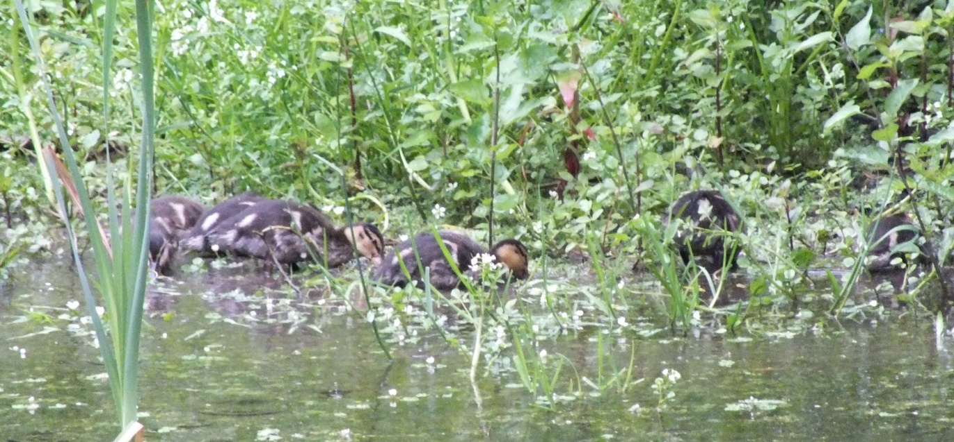

A family of Mallard ducks

**Butterflies**

Butterfly sightings between April and June have included Peacock, Comma, Brimstone, Small White, Speckled Wood, Green Veined White, Small Copper**,** Meadow Brown, Red Admiral, Large White, Orange Tip, Small Tortoiseshell and Ringlet.

**Monthly Records**

The month by month summary is shown below:

**April**

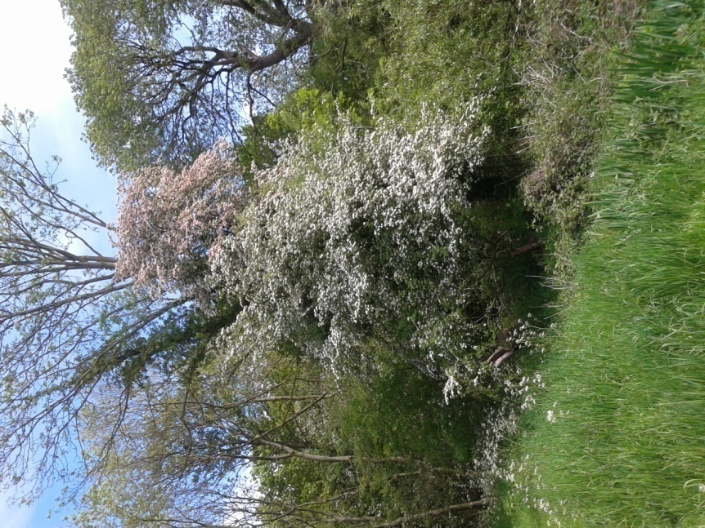The wet weather from March and the warm weather in early April encouraged many wildflowers to flower earlier than normal for the second year running. The following plants were all recorded in flower on the 10th April, Lesser Celandine, Daffodil, Primrose, Lesser Stitchwort, Daisy, Dandelion and very early Ramsons, Bluebell and Cowslip.

Blackthorn was in blossom and Hawthorn in leaf, by the end of the month. Red Campion, Dog Violet and Yellow Archangel were also flowering later in the month.

We spotted or heard 24 species of bird during April, these included unusual sightings of Tree Creeper, Green Woodpecker, Sparrow Hawk and Mistle Thrush on the 10th. Jays were also a regular sighting during the month. The summer visiting Chiff Chaff was heard in early April and Blackcaps had arrived by the month end. Other bird sightings of note included Buzzard, Bullfinch and Pheasant.

Early butterflies included Red Admiral, Comma and Brimstone in the later part of the month.

Blackthorn blossom

There was a lot of activity from the frogs and newts in the pond.

**May**

Butterfly sightings included Speckled Wood, Meadow Brown and all three whites, Large, Small and Green Veined. There were lots of Orange Tips seen this month, far more than last year. Other insects seen worthy of note were Violet Ground Beetle and Hornet.

Bird spotting highlights of the month were Swallow, Swift and Song Thrush on the 22nd May and a Willow Warbler on the 28th May. Other notable sightings included Greenfinch and Jackdaw.Both Mallard and Moorhen were seen on the pond with young chicks.

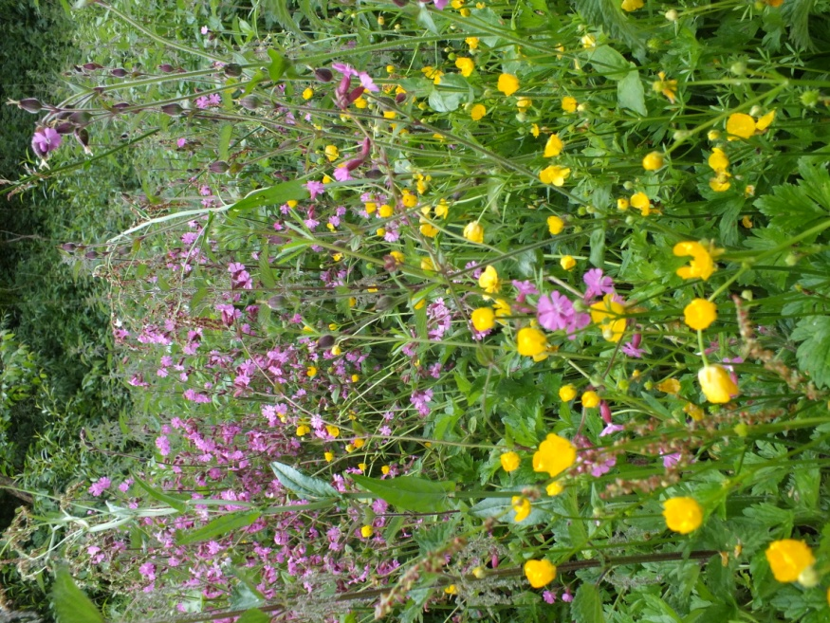Plants in flower included Lesser Stichwort, Herb Robert, Red Campion, Birds Eye Speedwell, Yellow Archangel and Rose Bay Willow Herb, with lots of creamy white Cow Parsley in the meadows.

Meadow flowers

The pond was looking and smelling nice with Water Mint, Water Forget-me-not, Water Bistort, Water Avens and Yellow Flag Iris all in flower. Great Crested Newt and Common Newt were recorded on the 28th May.

Bats seen or heard were Common Pipistrelle and Daubentons.

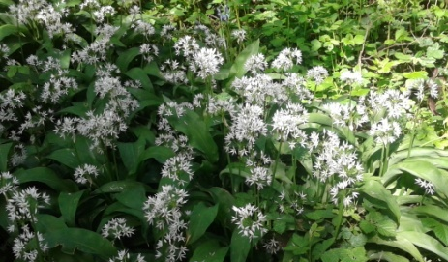

Ramsons (Wild Garlic)

**June**

Most plants have been flowering for weeks now, but new flowers in June included Foxglove, Meadow Sweet, Meadow Buttercup and Creeping Buttercup. The butterfly friendly Birds Foot Trefoil, (known locally as eggs and bacon), continues to do well in the wildflower meadow and the Yellow Rattle seems to be spreading.

Many young birds have been seen during the month, including Blue Tits and Great Tits (nesting in our nest boxes). We also saw young Robins, Wrens and Goldfinches. There were young Mallards and Moorhens on the pond, which is still looking good for water, probably thanks to the occasional heavy spells of rain.

The highlights of the many butterflies enjoying the spells of warm and sunny weather were Red Admiral, Peacock, and Small Copper. Towards the end of the quarter, there were lots of Ringlets and Meadow Browns seen in the meadows on the reserve.

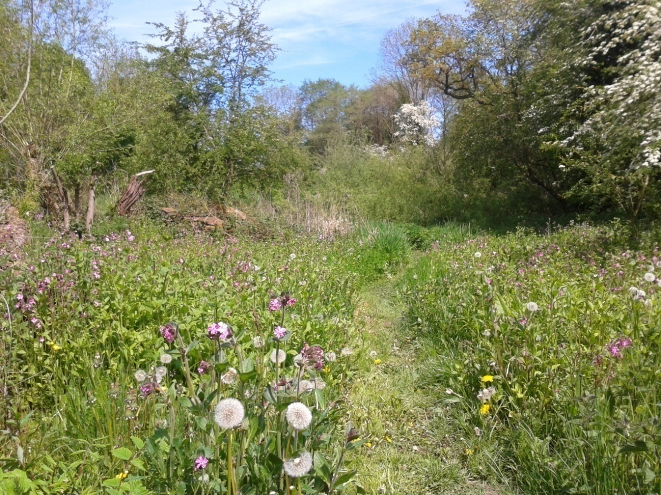

**Future Tasks**

During Quarter 2 (July to September 2019) the following meetings, practical days, events and activities are planned (please check with me before attending, as these dates may change)-

Wednesday 10th July (AM) Wildlife Recording

Wednesday 10th July FOG Meeting at 7pm

Saturday 13th July FOG Action Day and Charles Hill Community Event

Monday 15th July Conservation Volunteers Task Day

Wednesday 23rd July Newt Survey and Bat Recording

Wednesday 7th August Wildlife Recording Visit

Friday 9th August (pm) Conservation Volunteers Task Day – Mowing small meadow

Saturday 10th August FOG Action Day

Friday 30th August Conservation Volunteers Task Day – Main Meadow mowing

Friday 6th Sept Conservation Volunteers Task Day – Grass Removal

Wednesday 11th Sept FOG Meeting

Saturday 14th Sept FOG Action Day

Wednesday 18th or 25th Sept Wildlife Recording Visit